Optimal Number of Clusters
The objective of this document is to determine the optimal number of clusters for the customer dataset prior to running K-Means clustering.
The applied method is the Elbow Method, which is a standard informational method for calculating the required number of clusters (k) in k means clustering algorithm.
This method involves various steps:
The first step is running K-Means clusteringfor a range of cluster counts called as ‘k’.
Then, in the second step the inertiais computed within the cluster sum of squared distances to centroids for every‘k’.
The last step is plotting inertia versus ‘k’ and identifying the “elbow” point - the point at which the rate of decrease aggressively changes, showing reducing returns from adding a greaternumber of clusters.
Mathematically,
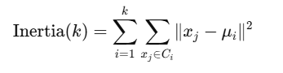

Where:
xj​ are the data points in the cluster and μi​ is the centroid value of the cluster
Visualization
The resulting line plot below also known as “Elbow Plot,” shows how the inertia value decreases as the number of clusters increases.
The point where the curve bends,making shape like an “elbow” shows the best number of clusters.
